**PROJECT REPORT**

**Airlines Data Analytics for Aviation Industry**

**TEAM ID :** PNT2022TMID13602

**TEAM MEMBERS :** Sathees Kumar.B

Naveen.G

Palani Kumar.V

Ravi Kumar.S

**1.INTRODUCTION**

Project Overview Purpose

**2.LITERATURE SURVEY**

Existing problem

References

Problem Statement Definition

**IDEATION & PROPOSED SOLUTION**

Empathy Map Canvas

Ideation & Brainstorming

Proposed Solution

Problem Solution fit

1. **REQUIREMENT ANALYSIS**

Functional requirement

Non-Functional requirements

1. **PROJECT DESIGN**

Data Flow Diagrams

Solution & Technical Architecture User

Stories

1. **PROJECT PLANNING & SCHEDULING**

Sprint Planning & Estimation

Sprint Delivery Schedule

Reports from JIRA

1. **RESULTS**

Performance Metrics

1. **ADVANTAGES & DISADVANTAGES**
2. **CONCLUSION**
3. **FUTURE SCOPE**
4. **APPENDIX Source Code GitHub**

**I.INTRODUCTION**

The aviation industry employs a diverse range of people with different characteristics and skill sets. At a macro level, the labor market is dependent on the market for the air transport services provided. But at a more granular level, the market is segregated according to job type, geographical location, and company, forming different markets with different characteristics which determine the wage that will be offered. It is a sector that has undergone substantial change over the decades, moving from strongly national structures to more deregulated competitive global operations.

New business models have been built on leaner and agile cost structures, achieved partly through more creative employment practices. This has impacted the labor markets and the relative power base between employer and employee. Economic shocks have also played their part in this evolution, with aviation usually a major casualty of economic downturns. Over the last year, COVID-19 has seriously curtailed worldwide travel, causing a 43% reduction in direct aviation jobs (ATAG, 2020). Although we expect a recovery post pandemic, there are some indications of a more fundamental change in international travel patterns, particularly the business sector.

**PROJECT OVERVIEW**

* The main aim is to provide better Airline and AirPort services and to avoid delays in Air Travel across different locations at Municipality level.
* It can be used to predict future glitches, prevent them from happening, and

make the maintenance procedures more accurate and thorough.

* data analysis on flight dataset to draw inferences on arrival and departure delays and to identify relationships between flight timings and delays. Using the flight delay data, we identified which flight is mostly prone to delays. The arrived upon conclusions are useful for selecting flights in the future.from the review of the customer and the flight which covers the destination in correct time and in shortest time that airline flight will be selected as a best airline service.

**PURPOSE:**

* Toprovide better Airline and AirPort services and to avoid delays in Air Travel

across different locations at Municipality level.

* The aim is to provide airports, airlines, and the travelling public with a neutral, third-party view of which airlines are delivering on their promise to get passengers from Point A to Point B on-time.
* Based on the third party review that is customer ,the best flight which covers

the destination in short time will be decided.

**2. LITERATURE SURVEY**

**TITLE :** On the relevance of data science for flight delay research.

**AUTHORS :** [Alice Sternberg](https://arxiv.org/search/cs?searchtype=author&query=Sternberg%2C+A), [Jorge Soares](https://arxiv.org/search/cs?searchtype=author&query=Soares%2C+J), [Diego Carvalho](https://arxiv.org/search/cs?searchtype=author&query=Carvalho%2C+D), [Eduardo Ogasawara](https://arxiv.org/search/cs?searchtype=author&query=Ogasawara%2C+E)

**YEAR :** 2017.

**DESCRIPTION :**

Flight delays are a significant problem for society as they evenly impair airlines, transport companies, facility managers, and passengers. Studying prior flight data is an essential activity for every player involved in the air transportation system. Besides, developing accurate prediction models for flight delays is a crucial component of the decision making process. Prescribing actions to solve on-going delays is an even challenging task due to the air transportation system complexity. In this regard, this paper presents a thorough literature review of data science techniques used for investigating flight delays. This work proposes a taxonomy and compiles the initiatives used to address the flight delay studies.

**PROS:**

* Accurately predicting these flight delays allows passengers to be well prepared for the deterrent caused to their journey .
* Enables airlines to respond to the potential causes of the flight delays in advance to diminish the negative impact.

**CONS:**

* Late due to weather predicting this is diificult.
* A few factors responsible for the flight delays like runway construction to excessive traffic are rare, but bad weather seems to be a common cause.

**TITLE :** Aviation management.

**AUTHORS :** Yogita Borse , Dhruvin Jain , Shreyash Sharma , Viral Vora, Aakash Zaveri

**YEAR :** 2020.

**DESCRIPTION :**

Flight Planning is one of the challenges in industrial world which faces many uncertain conditions. One such condition is delay occurrence, which stems from various factors and imposes considerable costs on airlines, operators, and travelers. Delays in departure can occur due to bad weather conditions, seasonal and holiday demands, airline policies, technical issue such as problems in airport facilities, luggage handling and mechanical apparatus, and accumulation of delays from preceding flights. Here in flight delay prediction system based on the weather parameters which can result in delays. The system considers the temperature, humidity, rain in mm, visibility and month number as important parameters for prediction of delay.

**PROS:**

* Advanced scheduling optimization tools for the better management of the available infrastructure and resources.
* Accurate timing information so that conflicts between aircraft are resolved.

**CONS:**

* Air traffic control operations and related issues are still scheduled by human controllers.
* Ignore any military/defence use of drones.

**TITLE :** Predictive Analytics Platform for Airline Industry.

**AUTHORS :** P. H. K Tissera, A.N.M.R.S.P. llwana, K.T. Waduge, M.A.l.

Perera, D.P. Nawinna, D. Kasthurirathna.

**YEAR :** 2020.

**DESCRIPTION :**

The research is to develop accurate demand forecasting model to control the availability in Airline industry. The primary outcome of the model is that the Airline organization can maximize the revenue by controlling the availability. The product in airline industry is the seat, which is an expensive, unstock able product. The demand for the seats is almost uncertain, the capacity is constraint and difficult to increase and the variable costs are very high.The revenue is derived by the number of passengers and the fares they pay which vary for each flight. Hence, it is challenging to develop an accurate method to project the revenue for each route.. We have the current ticketed revenue plus we have the current booked passengers. We also have the ticketed passenger details of previous flights.Hence most of the information is available, however changing market conditions is an unknown variable which can have a significant impact on passenger travel patterns.

**PROS:**

* Focus on the passenger demand forecasting,average fare forecasting,no show forecasting and visualizing the passenger demand and annual revenue prediction for od level point of sales. ● Reliability is improved.

**CONS:**

* With limitation of predictors because of sensitivity of the data and limited access to the data it may have impacted the models and the accuracy.

**TITLE :** Exploratory data analysis on aviaton dataset.

**AUTHORS :** Saba Firdous; Haseeba Fathiya; Lipsa Sadath.

**YEAR :** 2021.

**DESCRIPTION :**

The usage of big data analytics is booming today, with its ability to be used to draw useful insights from past data research. Its uses in the aviation industry have a wide array of applications ranging from predicting flight delays to detecting faults in airplane parts. In this paper, we conducted exploratory data analysis on flight dataset to draw inferences on arrival and departure delays and to identify relationships between flight timings and delays. Using the flight delay data, we identified which flight is mostly prone to delays. The arrived upon conclusions are useful for selecting flights in the future.

**PROS:**

* Data collected from customer profiles, social behavior, etc. can be efficiently used by airlines to provide personalized services to customers.
* They can also be used to analyze passenger flow, cost reduction and to enhance revenue.

**CONS:**

* When the number of flight arrivals and departures is very high, there can be an disparity between the capacity of the flight to handle the demands and its capacity, leading to many delays.
* Bad weather such as floods, hurricanes could also be the cause

**TITLE :** Forecast and analysis of aircraft passenger satisfaction.

**AUTHORS :** Xuchu Jiang , Ying Zhang , Ying Li , Biao Zhang.

**YEAR :** 2022.

**DESCRIPTION :** Airplanes have always been one of the first choices for people to travel because of their convenience and safety. However, due to the outbreak of the new coronavirus epidemic in 2020, the civil aviation industry of various countries in the world has encountered severe challenges. Predicting aircraft passenger satisfaction and excavating the main influencing factors can help airlines improve their services and gain advantages in difficult situations and competition. This paper proposes a RF-RFE-Logistic feature selection model to extract the influencing factors of passenger satisfaction. First, preliminary feature selection is performed using recursive feature elimination based on random forest (RF-RFE). Second, based on different classification models, KNN, logistic regression, random forest, Gaussian Naive Bayes, and BP neural network, the classification performance of the models before and after feature selection is compared, and the prediction model with the best classification performance is selected. Finally, based on the RF-RFE feature selection, combined with the logistic model, the factors affecting customer satisfaction are further extracted. The experimental results show that the RF-RFE model selects a feature subset containing 17 variables. In the classification prediction model, the random forest after RF-RFE feature selection shows the best classification performance. Finally, combined with the four important variables extracted by RF-RFE and logistic regression, further discussion is carried out, and suggestions are given for airlines to improve passenger satisfaction

**PRONS:**

* Found a positive relationship between customer satisfaction and a range of financial performance indicators by using the American Consumer Satisfaction Index.
* using flight data or text reviews to predict passenger satisfaction.

**CONS:**

* The evaluation indicators of passenger satisfaction surveys in the data set used in this study are not sufficient.
* Used the default parameters in the prediction model and did not consider the prediction results of different parameters.

**2.2 REFERENCE**

[1]. Leonardo Carvalho, Alice Stenberg, Leandro maia goncalves, Ana Beatriz cruz, Jorge A,soares, On the relevance of data science for flight delay research, 2018.

[2]. Shi Qiang Liu, Andrea D'Ariano, Erhan Kozan, Mahmoud Masoud

CARRS-Q, SaiHo Chung**,** Aviation management , 2019.

[3]. P. H. K Tissera, A.N.M.R.S.P. llwana, K.T. Waduge, M.A.l. Perera, D.P.

Nawinna, D. Kasthurirathna, Predictive Analytics Platform for Airline Industry , 2020.

[4]. Saba Firdous, Haseeba Fathiya, Lipsa Sadath, Exploratory data anlysis on aviaton dataset, 2021.

[5]. Xuchu Jiang , Ying Zhang , Ying Li , Biao Zhang, Forecast and analysis of aircraft passenger satisfaction, 2022.

**2.3 PROBLEM STATEMENT DEFINITION**

Reduction in overseas air travel was one of worst impacts of COVID-19 on the airline industry. Indeed, experts surmised that increasing number of travel restrictions in place, coupled with periodic lockdowns, will continue to affect the proportion of international air travel at least until 2023. Several countries banned flights in and out, to reduce the spread of the virus; prominent airline companies shutdown operations subsequently – an indicator of how COVID-19 disrupted the airline industry. Beginning March 2020, nations such as Albania, Angola, Argentina, Australia, Bahamas, Belgium, Japan, Mexico, Mauritius, New Zealand, Poland, Russia, and a number of others were among the ones that put forth a ton of travel restrictions, reducing air travel to a massive extent. Major air transport routes were shut down, and planned flights for the next few months were cancelled. Low international travel falls under one of the principal challenges faced by the airline industry due to COVID-19, with passengers, as indicated by surveys, likely to prefer places of travel with hygienic procedures and completed vaccination drives in the future.

1. **IDEATION & PROPOSED SOLUTION**

Average aircraft delay is regularly referred to as an indication of airport capacity. Flight delay is a prevailing problem in this world. It's very tough to explain the reason for a delay. A few factors responsible for the flight delays like runway construction to excessive traffic are rare, but bad weather seems to be a common cause. Some flights are delayed because of the reactionary delays, due to the late arrival of the previous flight. It hurts airports, airlines, and affects a company's marketing strategies as companies rely on customer loyalty to support their frequent flying programs

Nowadays, the aviation industry plays a crucial role in the world's transportation sector, and a lot of businesses rely on various airlines to connect them with other parts of the world. But, extreme weather conditions may directly affect the airline services by means of flight delays**.** Ultimate benefits of big data analytics include timely responses to current and future market demands, improved planning and strategically aligned decision making, as well as crystal clear comprehension and monitoring of all main performance drivers relevant to the airline industry. Data mining produces insights around the decisions for adding or subtracting the flights to the routes where more or lesser passenger movement is found.The purpose of this project is to look at the approaches used to build models for predicting flight delays that occur due to bad weather conditions. In this bsed on the customer review and other datas the delay of the flight is calculated then comparing with other flight the best flight with shortest time delay will be delivered.

* 1. **EMPATHY MAP CANVAS**

An empathy map is a collaborative tool teams can use to gain a deeper insight into their customers. Much like a user persona, an empathy map can represent a group of users, such as a customer segment. The empathy map was originally created by Dave Gray and has gained much popularity within the agile community.

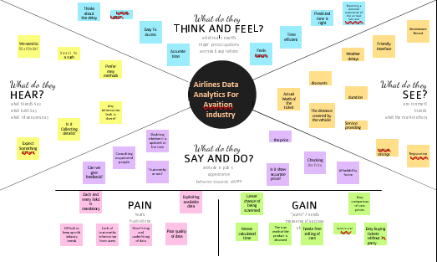

* 1. **BRAIN STORM:**

A mind map is a diagram used to visually organize information into a hierarchy, showing relationships among pieces of the whole. It is often created around a single concept, drawn as an image in the center of a blank page, to which associated representations of ideas such as images, words and parts of words are added. Major ideas are connected directly to the central concept, and other ideas branch out from those major ideas.

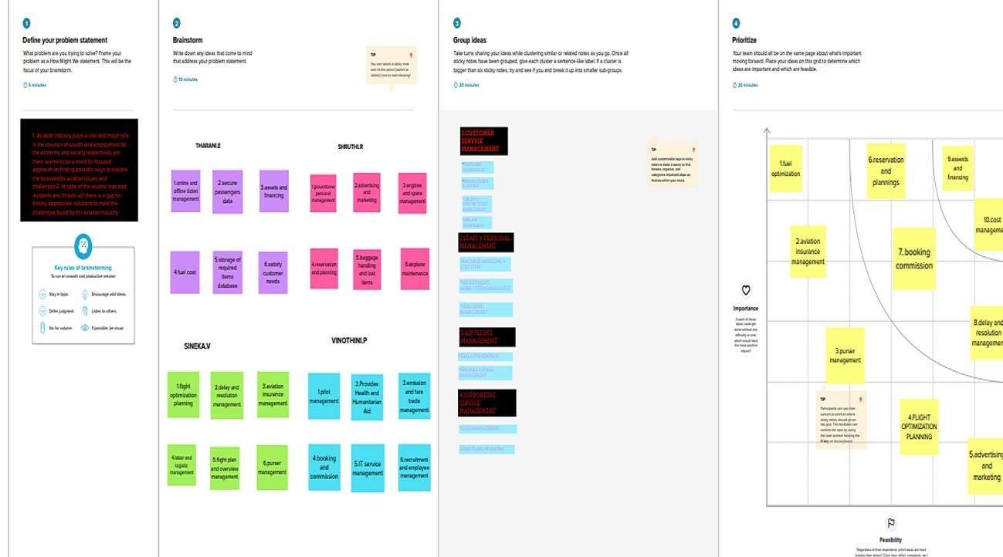

**3.3 PROPOSED SOLUTION**

|  |  |  |
| --- | --- | --- |
| S.No. | Parameter | Description |
| 1. | Problem Statement (Problem to be solved) | * To provide better airlines solutions and avoid flight delays during air travel across different regions. * This situation will result in the generation and the propagation of delays throughout the system, impacting   passengers’ quality of travel and  morebroadly the economy. |
| 2. | Idea / Solution description | * Airlines use this biometric technology as a boarding option. * Understanding traveler demand for specific city pairs and pricing flights can be done using data   analytics project. |
| 3. | Novelty / Uniqueness | * Unique Visualization of data from different datasets and unique graphical representation * Due to the use of smart data analytics, passengers will avoid many issues withbaggage tracking. |

|  |  |  |
| --- | --- | --- |
| 4. | Social Impact / Customer Satisfaction | * Data analytics helps the industry to understand customers’ preferences and other maintenance issues. * For instance, analysis of ticket booking helps the industry to target the customers with personalized offers while optimizing the price in real-time using predictive analysis techniques. As a result, by gathering meaningful data, airlines can fetch more bookings in the   given timeframe. |
| 5. | Business Model (Revenue Model) | * Creating a application in a subscription based model * A revenue model is a blueprint that shows how a startup business will earn revenue or gross income from its standard   business operations |
| 6. | Scalability of the Solution | * Aviation industry acting under international, domestic or private are also getting satisfied with the aviation   data analysing process provided as pertheir needs. |

**3.4 PROBLEM SOLUTION FIT**

Problem-solution fit is a term used to describe the point validating that the base problem resulting in a business idea really exists and the proposed solution actually solves that problem. Validate that the problem exists: When you validate your problem hypothesis using real-world data and feedback.

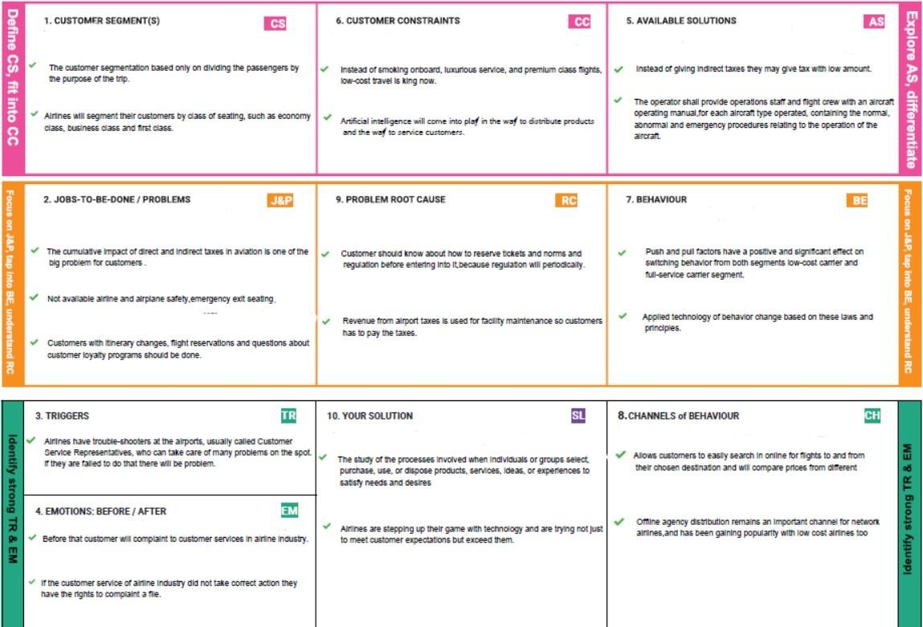

**4. REQUIREMENT ANALYSIS**

**4.1 FUNCTIONAL REQUIREMENT**

Functional requirements may involve calculations, technical details, data manipulation and processing, and other specific functionality that define what a system is supposed to accomplish.

Following are the functional requirements of the proposed solution.

|  |  |  |
| --- | --- | --- |
| **FR No** | **Functional Requirement (Epic)** | **Sub Requirement**  **(Story / Sub-Task)** |
| FR-1 | User Registration | Registration through Gmail. |
| FR-2 | User Confirmation | Confirmation via Email |
| FR-3 | Search for flights | The registered user can search one way,round trip and multiple destination flights by choosing specific dates and destination. |
| FR-4 | Specify passenger | Customer select the number of passengers and their category either adults,infant or child. |
| FR-5 | Sorting flight | Customer will sort the flight either by price or duration of the flight and will register. |
| FR-6 | Better airline service | Provide better airline service by analysing time consuming,comfort of passenger. |

**4.2 NON-FUNCTIONAL REQUIREMENT**

Following are the non-functional requirements of the proposed solution.

|  |  |  |
| --- | --- | --- |
| **FR No** | **Non-Functional**  **Requirement** | **Description** |
| NFR-1 | Usability | It defines how difficult it will be for a user to learn and operate the system and it can be assessed from different points of view. |
| NFR-2 | Security | Software is protected from unauthorized access to the system and its stored data.There will be more security to the passenger. |
| NFR-3 | Reliability | To ensure that the aircraft maintenance program tasks are effective and their periodicity is adequate. |
| NFR-4 | Performance | Revenue is often looked at on a passenger revenue per available seat mile basis. |
| NFR-5 | Availability | Where all required maintenance is accomplished and the aircraft is airworthy, as defined by the  regulations and is considered available for flight. |
| NFR-6 | Scalability | The capability of a system, network, or process to handle a growing amount of work. |

**5.PROJECT DESIGN**

**5.1 Data Flow Diagrams**

A Data Flow Diagram (DFD) is a traditional visual representation of the information flows within a system. A neat and clear DFD can depict the right amount of the system requirement graphically. It shows how data enters and leaves the system, what changes the information, and where data is stored.

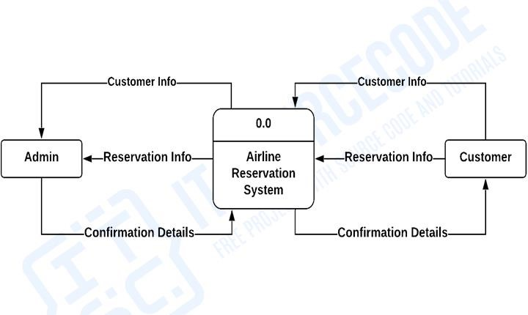

**5.2 SOLUTION AND TECHNICAL ARCHITECTURE**

Technical Architecture (TA) is a form of IT architecture that is used to design computer systems. It involves the development of a technical blueprint with regard to the arrangement, interaction, and interdependence of all elements so that system-relevant requirements are met.

The Deliverable shall include the architectural diagram as below and the information as per the Table1 & Table2.

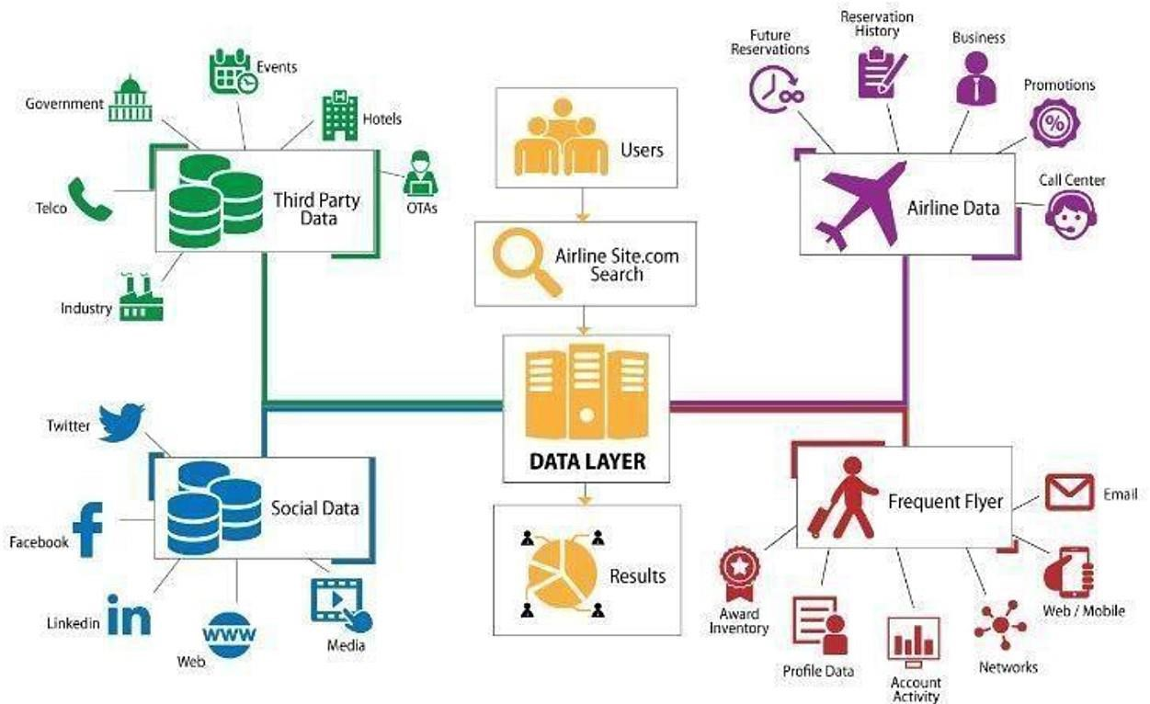

**Table-1: Components & Technologies:**

|  |  |  |  |
| --- | --- | --- | --- |
| **S.No** | **Components** | **Description** | **Technology** |
| **1.** | User Interface | How user interacts with application.  Example: Mobile App | HTML, CSS, Java  Script, Excel |
| **2.** | Application Logic-1 | Logic for a process in the application | IBM Watson STT service, Python |
| **3.** | Application Logic-2 | Logic for a process in the application | IBM Watson  Assistant |
| **4.** | Database | Data Type,  Configurations | MySQL, NSQL |
| **5.** | Cloud Database | Database service on cloud | IBM DB2, IBM  Cloudant |
| **6.** | File Storage | File Storage requirements | IBM Blocks Storage or other storage service or Local File system |
| **7.** | External API-1 | Purpose of External API used in the application | IBM Weather API |
| **8.** | External API-1 | Purpose of External API used in the application | Aadhar API |
| **9.** | Infrastructure  (Server/Cloud) | Application  Deployment on Local System/Cloud Local Server Configuration:  Cloud Server  Configuration | Local, Cloud  Foundry |

**Table-2: Application Characteristics:**

|  |  |  |  |
| --- | --- | --- | --- |
| **S.No** | **Characteristics** | **Description** | **Technology** |
| **1.** | Open-Source  Frameworks | List the open-source frameworks used. | Technology of opensource framework. |
| **2.** | Security  Implementations | List all the  security/access controls implemented, use of firewalls. | Example: SHA256,  Encryption, IAM Controls, OWASP. |
| **3.** | Scalable Architecture | Justify the scalability of architecture. | Cognos Used. |
| **4.** | Availability | Justify the availability of application (e.g: use of load balancers, distributed servers). | AWS Used. |
| **5.** | Availability | Design consideration for the performance of the application (number of requests per second, use of Cache, use of CDN’s). | Dashboard,Repor ts,Stories. |

**5.3 USER STORIES**

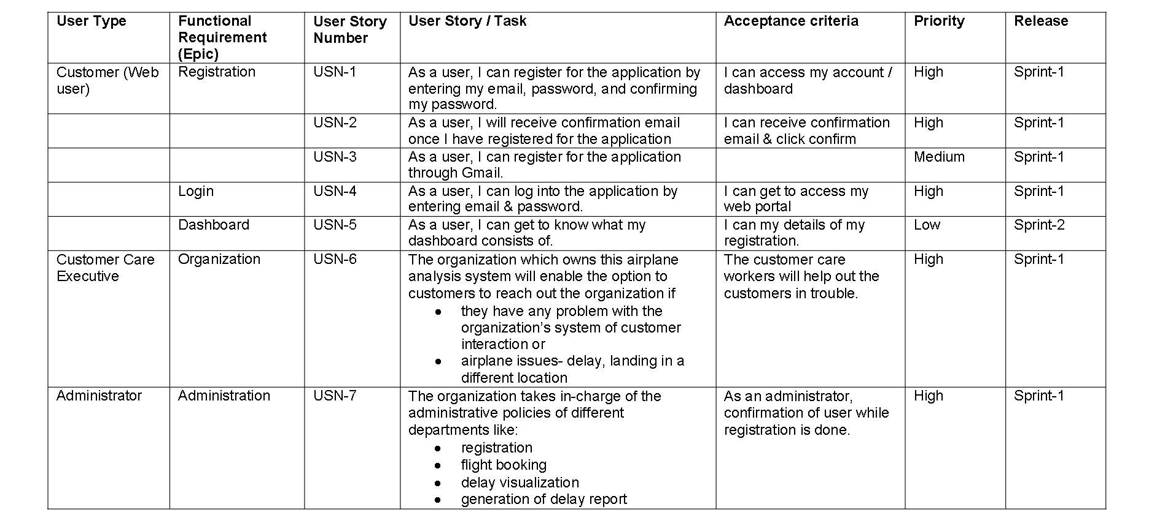

**6. PROJECT PLANNING & SCHEDULING**

**6.1 Sprint Planning & Estimation**

Product Backlog, Sprint Schedule, and Estimation

|  |  |  |  |  |  |  |
| --- | --- | --- | --- | --- | --- | --- |
| **Sprint** | **Function**  **al**  **Require ment**  **(Epic)** | **User**  **Story**  **Numb**  **er** | **User**  **Story /**  **Task** | **Story**  **Points** | **Priority** | **Team Membe**  **rs** |
| Sprint-1 | Retrieve the Data | USN-1 | Retrieving the data from the passengers those who are traveling in flight and the data of flight | 2 | High | SINEKA.V  SRUTHI.R |
| Sprint-1 | Visualize the data | USN-2 | After retrieving the data, we have to visualize the data for better understandi ng | 1 | High | THARANI.E  VINOTHINI  .P |
| Sprint-2 | Track the  flight  timing and  airline  names | USN-3 | Tracking the delays which are made by the flights and in other situations | 2 | High | SINEKA.V VINOTHINI  .P |
| Sprint-2 | Create interactive graph | USN-4 | At each scenario, we have to | 2 | High | SRUTHI.R  THARANI.E |
|  |  |  | create a graph for better visualization |  |  |  |
| Sprint-3 | Create dashboard | USN-5 | Creating interactive dashboard with the given dataset and information | 1 | High | SRUTHI.R  SINEKA.V |
| Sprint-3 | Creation of story | USN-6 | Creating the story for each respective phase |  | High | VINOTHINI  .P  THARANI.E |
| Sprint-4 | Predict the delays | USN-7 | Finally, this project delivers the airlines  which made most of the delays in  airport and flight | 1 | High | SINEKA.V VINOTHINI  .P |

**Project Tracker, Velocity & Burndown Chart**:

|  |  |  |  |  |  |  |
| --- | --- | --- | --- | --- | --- | --- |
| **Sprint** | **Total**  **Story Poin**  **ts** | **Durati on** | **Sprint**  **Start Date** | **Sprint**  **End Date**  **(Planne d)** | **Story**  **Points**  **Completed**  **(as on**  **Planned**  **End Date)** | **Sprint**  **Release**  **Date**  **(Actual)** |
| Sprint-1 | 20 | 6 Days | 24 Oct 2022 | 29 Oct 2022 | 20 | 29 Oct 2022 |
| Sprint-2 | 20 | 6 Days | 31 Oct 2022 | 05 Nov  2022 | 20 | 05 Nov 2022 |
| Sprint-3 | 20 | 6 Days | 07 Nov  2022 | 12 Nov  2022 | 20 | 12 Nov 2022 |
| Sprint-4 | 20 | 6 Days | 14 Nov  2022 | 19 Nov  2022 | 20 | 19 Nov 2022 |

**6.2 SPRINT DELIVERY SCHEDULE**

**MILESTONE&TASKS**

|  |  |  |
| --- | --- | --- |
| **Milestone** | **Task** | **Duration** |
| Milestone-1 | Collection of Datas | October-24/10/22 |
| Milestone-2 | Uploading the required datas on the platform | October-27/10/22 |
| Milestone-3 | Visualizing of data | October-30/10/22 |
| Milestone-4 | Creating a dashboard | November-2/11/22 |
| Milestone-5 | Display the datas in the dashboard | November-5/11/22 |
| Milestone-6 | Prepare a standardized data set and using the datas required with the help of python program | November-8/11/22 |
| Milestone-7 | Usage of various algorithm to obtain the desired result | November-11/11/22 |
| Milestone-8 | Display them in the required format | November-15/11/22 |
| Milestone-9 | Deployed in the github | November-19/11/22 |

**7.RESULTS**

**PERFORMANCE METRICES**

There are various metrics to calculate the efficiency of the data models itself. Performance of a data model developed by data scientists is a direct way to measure their efficiency. Methods include confusion matrix, F1 score, PrecisionRecall Curve, Receiver Operating Characteristics, among others. The idea is to see if the performance is better than the baseline models. It is important to consider that a model takes time to improve and that models are not foolproof.

In this project with the help of the data analytics the flight which covers the destination in short time when comparing to the another flight is calculated easily with more accuracy.The accuracy rate is more high by using a data analytics.

**8.ADVANTAGES AND DISADVANTAGES**

**ADVANTAGES:**

* The advantages include being able to fly to almost any destination in the world and having a variety of different aircraft for different purposes, and cut down on travel time.
* High Speed - It makes this model an optimum choice if the client has an urgent need to ship a product . It is the quickest transport mode and is therefore ideal for long-distance transport of goods.
* There is less need for heavy packaging - Air exports, in general, entail less hard packaging than ocean shipments. This ensures you save both time and money by not having to provide extra packaging services.
* Fast Service - Air transportation offers convenient, reliable and fast services of transport. It is considered the cheapest way to ship peregrinated goods.

It offers a standard, convenient, reliable and fast service.

* Natural Route - An aircraft can fly to any location without seeing any natural obstacles or barriers. Since customs formalities are easily compiled. It eliminates the need for more time to seek clearance. Air travel is used for relief operations during earthquakes, floods, accidents, and famines.

**DISADVANTAGE:**

* Risky - Air travel is the riskiest mode of transport, since there can be considerable losses to goods, customer and crews as a result of a minor crash. Compared to other means of travel, the risks of collisions are higher.
* Cost - Air travel is considered to be the most expensive means of transportation. The cost of maintaining aircraft is higher and the costs for the building of aerodromes and avions are much higher. That’s why air travel is so expensive that it gets beyond ordinary people’s grasp.
* Capacity for Small Carriage - The aircraft have no room and therefore are not ideal for carriage of voluminous and cheaper materials. As is seen for rails, the load volume cannot be raised.
* Accident-prone - Compared to other modes air travel is always at high risk of accidents. There are more accidents on count while travelling by air transport. The reason can be bad weather, signal issues or machine parts failure which causes loss of people, crew or goods.

**9. CONCLUSION**

Customer experience is always at the top of the priority list for airlines. Customers that are dissatisfied or disengaged inevitably result in fewer passengers and less money. It is critical that clients have a positive experience every time they travel.Looking at the bright prospects of the aviation industry, it makes sense to invest in airline stocks as they are likely to benefit from the government’s push to make the aviation industry a bulwark of the transportation industry in India.

From this project we conclude that ,The usage of big data analytics is booming today, with its ability to be used to draw useful insights from past data research. Its uses in the aviation industry have a wide array of applications ranging from predicting flight delays to detecting faults in airplane parts. In this paper, we conducted exploratory data analysis on flight dataset to draw inferences on arrival and departure delays and to identify relationships between flight timings and delays. Using the flight delay data, we identified which flight is mostly prone to delays. The arrived upon conclusions are useful for selecting flights in the future.from the review of the customer and the flight which covers the destination in correct time and in shortest time that airline flight will be selected as a best airline service.

**10. FUTURE SCOPE**

With the growth of data, the use of analytics in the airline industry is the next big wave. The ultimate benefits of big data analytics include timely responses to current and future market demands, improved planning and strategically aligned decision making, as well as crystal clear comprehension and monitoring of all main performance drivers relevant to the airline industry.

In future this project has been developed with some extra features.The customer can give query for any dissatisfication that query will be solved review of the customer will be collected.Then if a customer want to change the destination in a midway they can give one alert message to the service and that nearby destination will be given for the customer.

**11.APPENDIX**

**GITHUB LINK:**

[**https://**](https://github.com/IBM-EPBL/IBM-Project-5128-1658747959)**github.com/**[IBM-EPBL](https://github.com/IBM-EPBL)/[**IBM-Project-30941-1660193067**](https://github.com/IBM-EPBL/IBM-Project-30941-1660193067)